NMRNH Ground Floor Rolling Deep Clean Programme
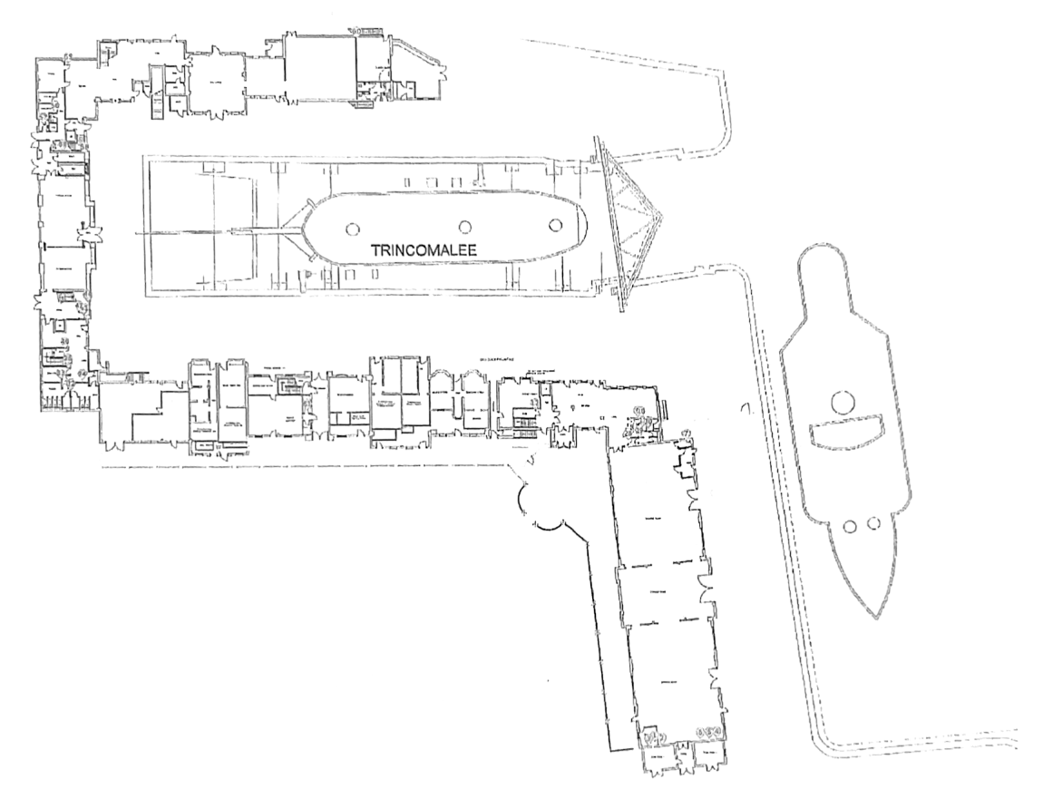
Zone 1
Zone 2
Zone 3

Zone 4

Daily Tasks

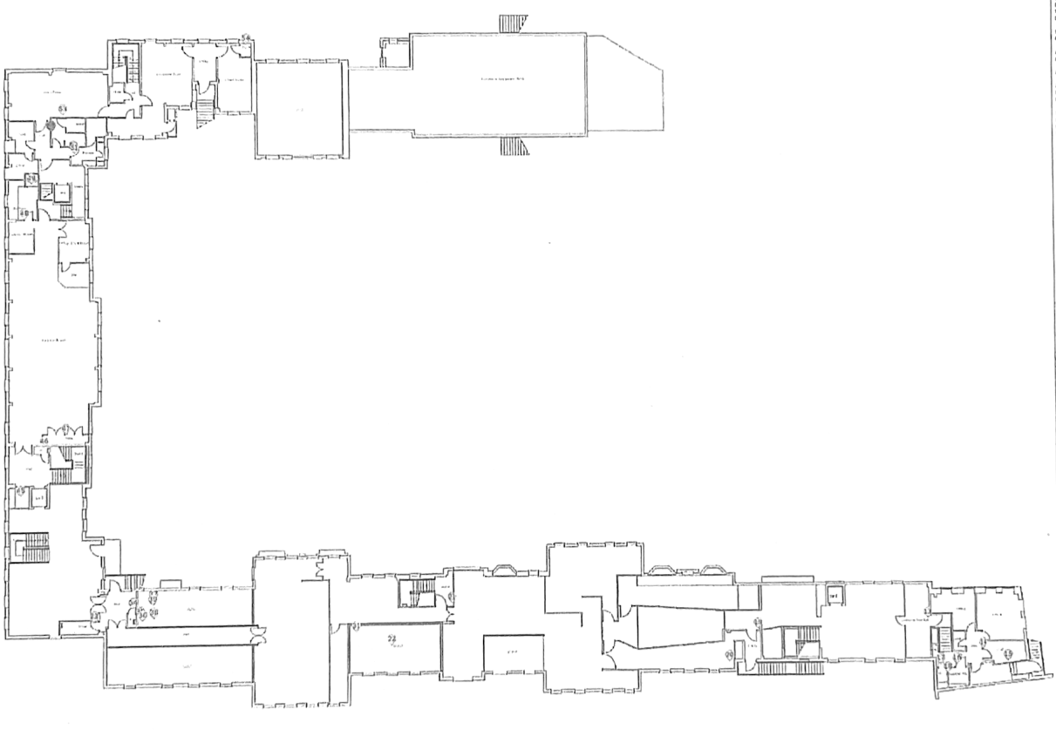
NMRNH Ground Floor Rolling Deep Clean Programme

